How to Add a Blog Post in WordPress

- On the Moral Moments website (moralmoments.psu.edu), click on “Log In” in the upper left-hand corner.
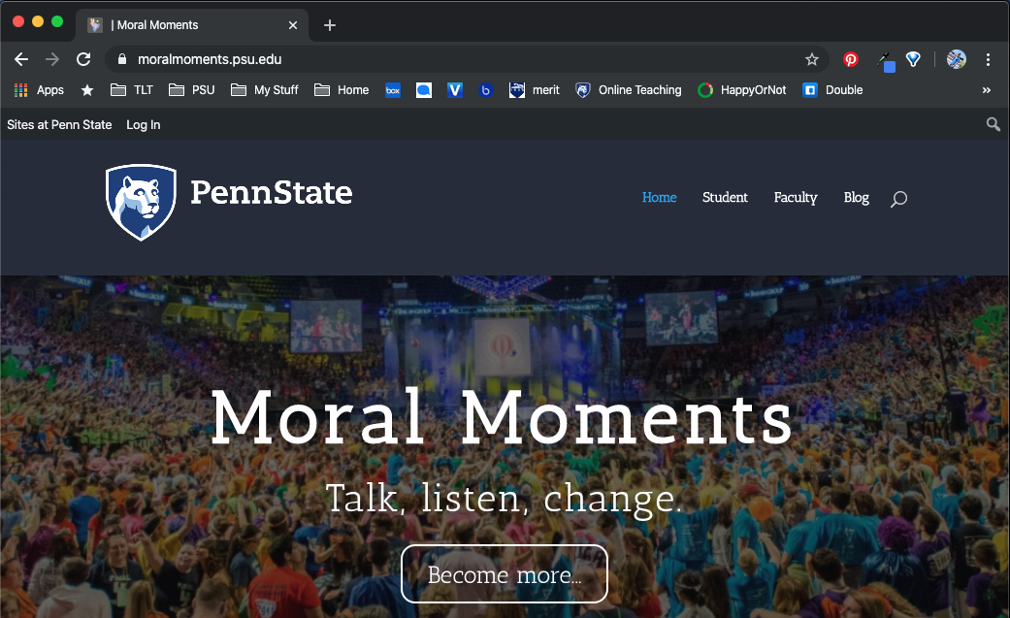
1.

- This will change the web address to sites.psu.edu/moralmoments. Next, hover (do not click) your mouse over “+ New”.

- A drop-down menu will appear. Click on “Post”.

2.
3.

- Your screen should now look similar to the below image. Add your title here.

- Share your learning activity, resource, or story. This is similar to any word processing or document creation tool (e.g. Microsoft Word, Google Docs). Feel free to stylize your post using the provided formatting options.

- Once finished, click the blue “Publish” button and your post will appear on the Moral Moments Blog page.
4.
5.
6.

*We reserve the right to remove any content that is deemed inappropriate to Moral Moments.

