How to Import into your Course

Except where otherwise noted, content in Moral Moments Canvas courses is licensed under a Creative Commons Attribution-NonCommercial 4.0 International License.

If you plan on importing into a master course, begin with step one. If you plan on importing directly into your live LionPATH course, skip to step four.

- From your Canvas Dashboard, select “Request a Master or a Manually Enrolled Course” under “Request Course Spaces”. Depending on the size of your screen, this will either be to the right of your course cards or underneath them.

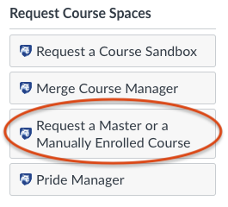

- Fill out the form for a master course. Here is an example of the information you will need to fill out:
  - Request Explanation: prep space for a live course I will be teaching in X semester
  - Course Type: Master Course
  - Course Name: name this something that you will understand
  - Short Title: a shortened version of the “Course Name”
  - Course Term: choose the current term or the term you will be teaching the live course
  - Add Course Instructor(s): add your PSU user ID and any others you wish to have access to your master course
  - Location: Selection your campus, college, and department.
  - Be sure to click the blue “Submit” button when you are finished filling out the form.

- Wait for an email from Penn State Service Management. The email subject line will look something like this: Incident INC####### has a new comment and will notify you that your master course has been created.

- Locate your course on your Canvas Dashboard and open it.

- Select “Settings” from your course menu.

- Select “Import Course Content”. Depending on the size of your screen, this will either be on the far right or near the bottom of the page.

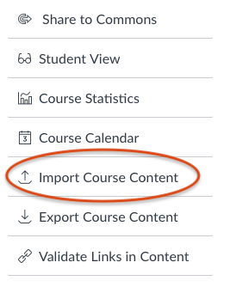

- Choose “Canvas Course Export Package” from the dropdown menu.
  - Click the “Choose File” button and locate the export package file that you downloaded with these instructions.
  - Select the “All Content” radio button.
  - It is your choice if you’d like to select “Adjust events and due dates” under Options. Selecting this box will give you two options: shift dates and remove dates. Remove dates may be your best option. This will give you a clean slate to add due dates that fit best with your schedule. If you select shift dates, it is highly recommended to go through all of the dates to double check this worked properly.
  - Be sure to click the blue “Submit” button when you are finished filling out the form.

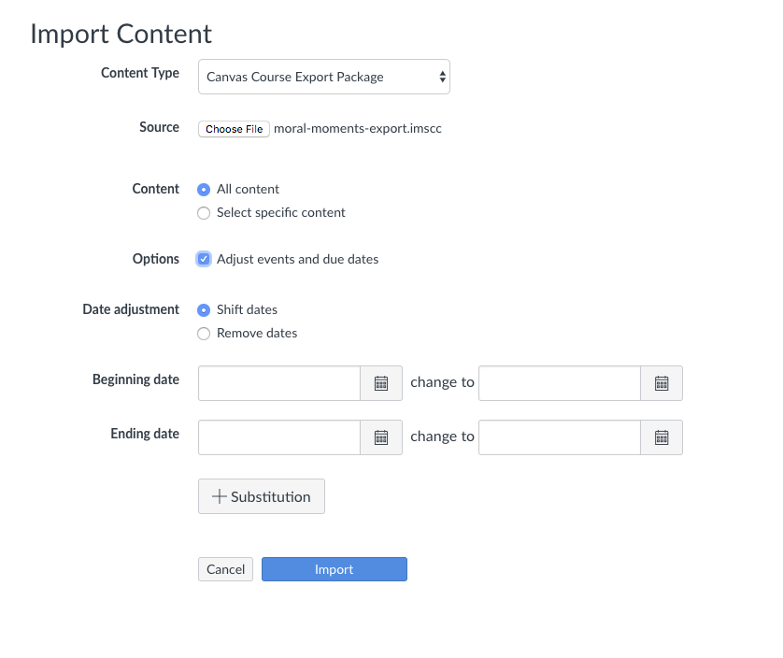

- The import will show up under “Current Jobs” directly below the “Import Content” section. You will see a green “Completed” icon when the export has finished. Click on “Home” from your course settings and voilà, you have successfully imported content into your course!

